
Robotic Self Feeder for Children with Cerebral Palsy
2009
Preliminary Design Report
Submitted by:
Cynthia Ericksen _______________________________________________________
Mallory Jensen ________________________________________________________
Monica Sachs _________________________________________________________
Monica Thomas ________________________________________________________
Faculty Advisor:
Prof. Katherine Kuchenbecker
__________________________________________________________
Dept. of Mechanical Engineering and Applied Mechanics

Submitted in partial fulfillment of the requirements for MEAM 445
December 10, 2009

Table of Contents

- Title Page ………………………………………………………………………….……...1
- Table of Contents…………………………………………………………………..……...2
- Executive Summary…………………………………………………………………..…...3
- Purpose and Requirements…………………………………………………………….......4
- Design Concept……………………………………………………………………….…...4
- Configuration and Performance…………………………………………………………...7
- Test and Evaluation…………………………………………………………………........15
- Bills of Materials……………………………………………………………………..…..17
- Project Plan……………………………………………………………………………....18
- Risks……………………………………………………………………………………..21
- References and Acknowledgements..……………..…………………………………….22
- Appendices……………………………………………………………………………....22

1. Executive Summary
Our project is a collaborative effort between MEAM Senior Design and the HMS School for Children with Cerebral Palsy. Spastic cerebral palsy classifies 70-80% of all recorded cases of Cerebral Palsy (Dormans, 1998). This type is characterized by hypertonia, abnormal postures, and spasticity. As a result of these complications and others, many cerebral palsied children face day-to-day feeding challenges. These children must be fed in a specific way and reminded to chew and to swallow. Unless a self-feeder is used, a specially trained aide must feed the child that has cerebral palsy until he or she develops the required motor skills. This process can be time-consuming, difficult, and demeaning to cerebral palsied children. To remedy this situation, we are designing a robotic feeding system for the students at the HMS School for Children with Cerebral Palsy. While some systems like this already exist, they are often expensive, easy to break, and have problems with food delivery.
Our device is a three bar electromechanical linkage with a spoon-like end effector that delivers food to the user. The food will be placed in four different bowls that attach to a plate. This plate will rotate so that the desired bowl is always placed in the same location with respect to the linkage. This device will illuminate LED’s under each bowl position, one by one. When the desired food item is lit up, the student will press a button to activate food delivery. The button that the students press will be one large button. When the student presses the button, the system will pick up food from the bowl that the student specified. Then the food will be delivered to a set location in front of the student’s mouth. Once the student is finished eating a spoonful they will hit the button again to retract the spoon. This will bring the linkage back to its original position. In order to preserve the safety of the student, the feeder will move slowly and deliberately toward the student’s mouth. Another safety measure that will exist is that the student may hit the button if they get scared and want to stop the spoon from coming to feed them at any time.
In order to complete our project we split the system into three subsystems: food pickup, delivery actuation, and user interface. The delivery actuator, being the most critical part of the project was developed this semester. Our prototype consisted of the three link linkage and three motors with potentiometer position control. MATLAB scripts showing desired linkage trajectory were also included. Through testing, we have found a few necessary improvements to linkage actuation. We are ordering a new motor for the second link as well as increasing the gear ratio for the first motor to increase torque. For next semester, we plan to split into two work forces. One will continue working on the delivery actuation, while the other team will work on the food pickup subsystem and the user interface. Throughout each subsystem we will be completing multiple tests to assure that each subsystem works before integration. There will also be sufficient testing with the device as a whole. For this we will be testing the device by building a target board, which, for safety reasons, will take the place of a human subject for the first round of testing. Using this setup, we will test the cleanliness of food delivery, end effector target accuracy, and safety. The target board will be made out of a material similar to foam core. We will also be testing with ourselves to try and put ourselves in the student’s shoes and see how our device is really performing. Throughout the design process we will bring prototypes to the HMS school to showcase to the food specialists. The food specialist’s feedback will determine our success from the point of view of the intended user.
Some of the risks we may face with our project are the risk of the spoon impacting the student as well as the danger of using motors. To avoid these risks we plan to do extensive testing during development and to incorporate factors of safety. To prevent the spoon from physically impacting the student we plan to set a limit of how close the end effector can get to the student. A measuring device will be included for the aide to use to ensure that the device is positioned at the correct location. We will also incorporate a shut down mode if the feedback control system notes any deviation in link positions from the planned trajectory (ie., if someone bumps into the device). If our preventative measures are not sufficient we will increase the factors of safety on the design as well as possibly add additional control measures.

2. Purpose and Requirements
The purpose of this project is to develop a robotic self - feeding system for children with Cerebral Palsy. The requirements and objectives we are setting are as follows in Table 1.
Our project must…  - Feed the user  - Deliver food to the user’s mouth  - Preserve the user’s safety  - Preserve the user’s dignity  - Fit through doorways during transportation  - Activate at user’s signal  - Provide enough food for one meal | Our project should…  - Have an emergency stop to preserve safety  - Function without constant outside assistance  - Offer a choice of food  - Fit in the trunk of a car  - Be discrete – quiet  - Be able to be transported by one person  - Be backdrivable
Table 1 - Requirements
3. Design Concept
3.1 Overview
The user interface system will scan through food choices. The student will press a button when the desired food bowl is highlighted. This will start the food delivery process. The base plate that holds the bowls will rotate so that the correct food is placed in front of the robot arm. The spoon end effector will be placed inside the bowl and glide along the bottom of the bowl. The spoon will scrape along the lip on the far side of the bowl and then complete its trajectory at a destination near the student’s mouth. After the student finishes a bite, he or she will press the button again to send the spoon back to its initial position. The entire device will be height-adjustable and able to be placed anywhere on a table or other flat surface.

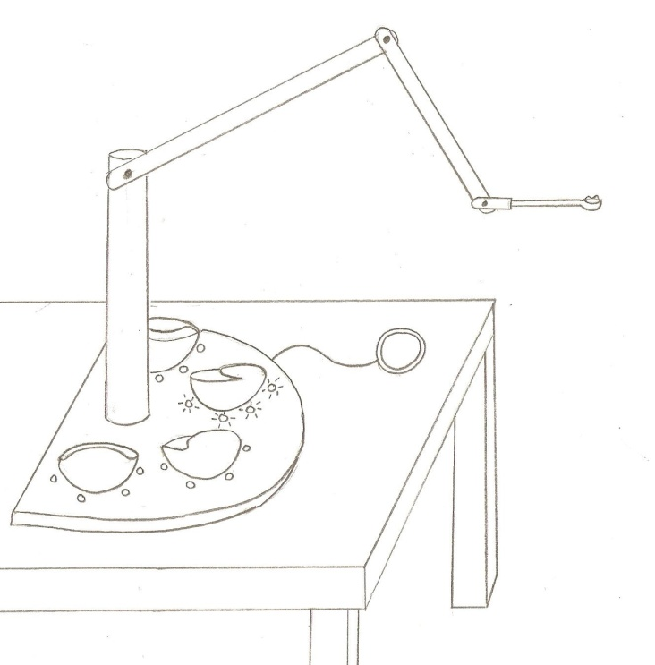
Figure 1 - Design concept for the feeding device. The student would be seated to the right of this figure.

3.2 User Interface
The user interface will be a scanning system using LEDs. There will be LEDs surrounding each of the bowls. The system will scan through the food choices by lighting up each bowl for a few seconds. When the desired food choice is highlighted, the student will press a button to begin the food delivery process.

3.3 Activation
The feeding process will be initiated with the press of a large button. After the student completes a bite, he or she will press the button again to send the spoon back to its initial position. If at any point during food delivery the student wants to stop the device, he or she can press the button and the motion will stop. The decision of whether the arm will retreat back to its initial position or only pause its motion until the button is pressed again will be determined by a predefined state diagram embedded in the code. The button was chosen because it is the simplest activation device for students with cerebral palsy to operate. The button’s cord will have to be long enough so that it can reach the student.

3.4 Arm Linkage System
The arm of the feeding device is a three degree-of-freedom, planar robotic linkage with revolute joints to connect each link. The first link will be attached to a motor on a vertical column base. The third link will consist of the Maroon Spoon, used by several students at the HMS school, and an attachment piece to connect it to the third motor shaft. The spoon can be easily removed for cleaning or replacement. The end effector will always move through the same trajectory, starting near the edge of the bowl and ending near the student’s mouth.

3.5 Motors and Sensors in Arm Linkage
Currently, each joint of the robotic linkage is powered by a DC motor. In the future, cable and belt drives will be considered. Potentiometers and encoders will be used for position readings at each joint.

3.6 Base Plate
There will be a semicircular base plate that the bowls will connect to. This plate will rotate about the base column to place the correct food choice in front of the linkage arm. It will be powered by a single DC motor. LEDs will be embedded in the plate to light up the food choices for the user interface. This base will rest on the dining table.

3.7 Bowls
There will be four bowls of identical shapes in different colors to hold the food options. A key requirement of the bowls is that they must be curved such that the spoon can glide along the bottom without breaking contact. They have to be shallow enough so that the spoon can reach the bottom and wide enough so that the bowls collectively contain enough food for one meal. Each bowl will have sloped sides so that it makes a trough that will force food to drop into the middle of the bowl. The bowls will also have a lip that extends from the rim horizontally into the inner portion of the bowl. Figure 2 shows this lip feature. The spoon will scrape along this lip after the food is loaded to ensure that the food is compacted and that there is no excess food on the spoon. The first bowl will be 3D printed. The remaining three bowls will be molded. The bowls can easily be removed from the base plate for cleaning.

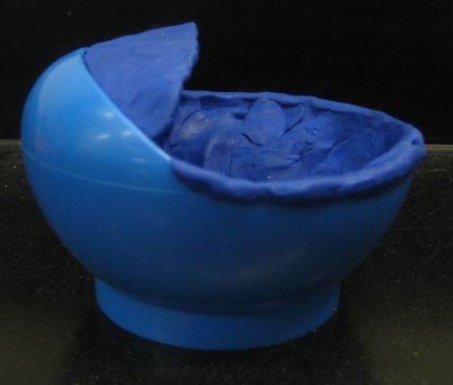
Figure 2 - Prototype of bowl design with lip feature

3.8 Power Source
The device will ideally be battery powered with a wall plug-in option.
3.9 Size/Portability
The fully extended linkage arm will be 29 inches. The base column will 12 inches tall. The semicircular base plate will have radius of 7 inches. For transport, the arm will be able to be laid down along the base column, with the bowls removed and the button’s cord disconnected. The device should be light enough so that one person can carry it and small enough so that it can fit through a doorway.

4. Configuration and Performance
4.1 Workspace
The workspace was defined based on conversations with the feeding specialist at the HMS school and by observing the students eat during lunch time. The arm will exhibit planar motion to simplify the design and reduce costs. The device can be oriented so that the arm moves diagonally towards the student if he or she is more comfortable with this approach. We determined that the arm would need to be 29 inches minimum when fully extended to comfortably feed the student. The device should be height adjusted so that the base joint is level with the student’s mouth. The base joint is 12 inches above the base plate. The top of the bowl is 3 inches above the base plate and 3.5 inches horizontally from the centerline of the base column. The bowl has a diameter of 4 inches. The lip of the bowl extends 2 inches from the rim horizontally to the inner portion of the bowl. The exact slope of the bottom of the bowl is only roughly defined until the bowl design is finalized.
4.2 End Effector Trajectory
Using this workspace, a set of points was chosen to define the end effector trajectory. It was also determined that after the food is loaded onto the spoon, the spoon must remain horizontal for the remainder of the delivery.
4.3 Link Lengths
After we determined that the linkage would require a 29-inch maximum reach, we experimented with a foam core representation of the workspace to determine the length of each link. The first link is 13 inches, the second is 10 inches, and the third, including the spoon, is 6 inches.
4.4 Defining the Joint Angles
Using the predefined Cartesian coordinates of the end of the spoon and the angle that the spoon should be with respect to the ground, inverse kinematics allowed us to determine the angles of the links at each time step. The calculations for this are shown in Appendix 10.1. The matrix of all angles the arm must pass through at each time interval will be programmed onto the microcontroller.
4.5 Joint Angular Velocities
The Jacobian was computed to relate the angular velocities to the end effector velocity:
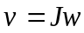
where v is the end effector velocity, J is the Jacobian, and w is the angular velocity.
The Jacobian was found to be:
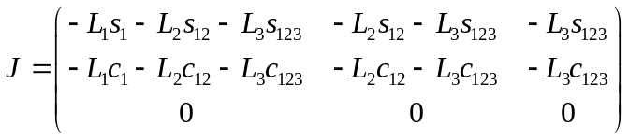
where
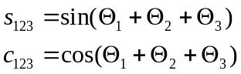
The transpose of the Jacobian matrix is used to relate the forces at each joint to the torques needed for each motor.
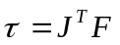
The Jacobian will help us to determine the power requirement of our motors for a given angular velocity and required torque.

4.6 Motor Selection

Our robotic arm requires actuation at each joint to achieve its desired position via a smooth trajectory. To accomplish this, we chose to place a motor at each joint. We first considered purchasing and implementing DC servo motors. These motors are equipped with an angle sensing system and are designed to respond to angle commands. However, servos are used mostly for hobby-type projects (Ex. homemade helicopters, planes, and robots) and do not report angular positions. Instead, servos simply accept an angular value, do their best to move the motor shaft to that value, and assume that the user does not care to check the position.
DC gearhead motors proved to be the best choice for our project. By purchasing motors without a pre-designed control system, we had the freedom to design the system to our liking. For our project and for robotic arms in general, angle accuracy is extremely important. Small deviations in each joint can lead to a skewed end effector position, which would defeat the purpose of our project. For our December functional prototype, we used two DC gearhead motors which we equipped with sensing systems and control loops.
In selecting the DC motors for our prototype, we considered the torque each motor would require to hold up the subsequent links, their motors and additional hardware, as well as the weight of the food. We determined torque on each motor by assuming the maximum torque situation would occur when the arm was fully extended. Torque was calculated by balancing the moments about the base joint. The script calculating the torque at each joint as a function of link length, material, motor weights and hardware weights can be found in Appendix 10.2. These torques represent values for the “Maximum Continuous Torque,” a value normally reported by motor manufacturers. While we did not consider power requirements for our first prototype, we plan to account for desired angular velocities at our required torques for our next motor purchases.

From our calculations, we found that the torque at the spoon joint (Joint 3) should be 37.4 mNm, the torque at the middle joint (Joint 2) should be 265.5 mNm, and the torque at the base joint (Joint 1) should be 1028 mNm. For Joint 3, we chose the 212-403 Precision Microdrives DC motor. This motor has an open gearbox with a 298:1 gear ratio. Its peak efficiency torque is 59 mNm. For Joint 2, we chose the GM3 from Solarbotics. This 224:1 gearmotor has a stall torque of 423 mNm, which is well above the required continuous torque for this joint. Finally, for Joint 1, we borrowed a large Maxon motor from the Haptics Lab. Because Joint 1 requires so much torque, purchasing a motor geared to this torque can become expensive. The motor we borrowed cannot deliver over 1028 mNm of torque, but with the help of a gear ratio, we hope that it will be able to hold our robot arm. If we are successful in creating our desired torque, we can search for a cheap DC motor with the same specifications as the Maxon motor.

4.7 Angle Sensing

As previously mentioned, accurate angle sensing is crucial to the success of our project. Ideally, each motor should have two sensing devices (Ex. a potentiometer and an encoder). If there are large deviations between the angles reported by each device, the robot arm is in an unknown position and will need to stop motion immediately to be recalibrated. For our functional prototype, we chose to use only one sensing device at each joint. Linear rotary potentiometers sense joint angles 2 and 3. These potentiometers were borrowed from the GM lab. Each has a circular shaft that can rotate about 300 degrees.

To confirm that these potentiometers were linear and to determine the conversion factor from digital values to angular position, we used the MaEvArM with a USB serial interface. We placed the potentiometers on a protractor with one extreme position coincident with 0 degrees. At 0, 45, 90, 135, 180, 270, and 300 degrees, we recorded the decimal values (converted from analog voltages to digital values by the microcontroller) reported on the computer screen. Figures 3 and 4 show plots of angular position versus decimal value. The slopes of these lines determine the conversion factors (decimal/degree). For the Joint 3 potentiometer, the conversion factor was 3.3 (with inverse 0.3). For the Joint 2 potentiometer, the conversion factor was 4.14 (with inverse 0.24).
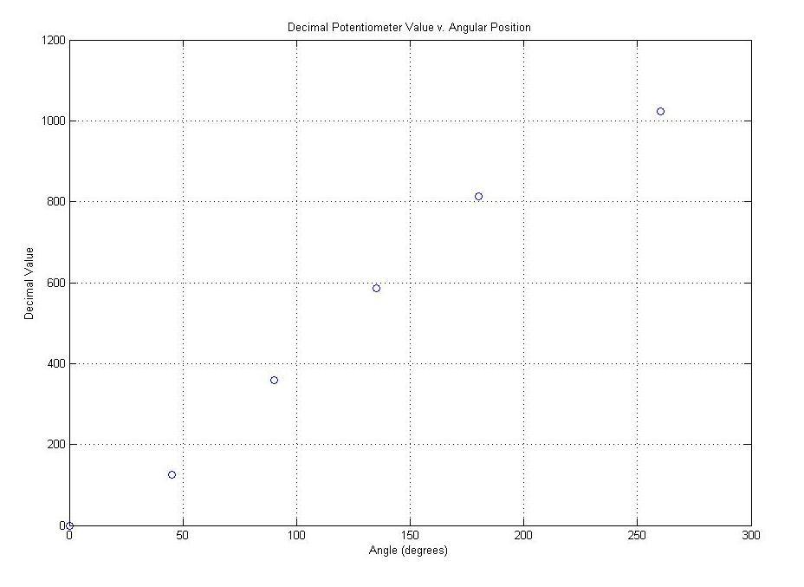
Figure 3 – Decimal Potentiometer Value v. Angular Position for Joint 2
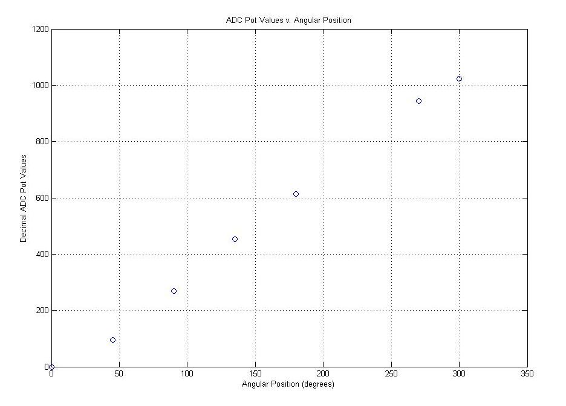
Figure 4 - Decimal Potentiometer Value v. Angular Position for Joint 3

In the microcontroller, the ADC value is multiplied by the inverse of this conversion factor:
ADC_to_degrees = 3;
theta_deg = ADC*ADC_to_degrees;
theta_deg = theta_deg/10;
ADC represents the analog voltage converted to a digital value by the microcontroller. In the above example, the decimal/degree factor is 0.300. Because the microcontroller only recognizes integers, a special syntax is required to handle this multiplication.
4.8 Control System
To correct for errors in angular position, a simple control loop is required. For our functional prototype, we used only a proportional term. For our final prototype, we plan to use an integral term and a derivative term if necessary. In our proportional control loop, error is determined by a difference between desired angle and actual angle (as reported by the potentiometers). This error is multiplied by a proportional gain (K_{p}) to control the response of the motor. The algorithm is as follows:
- Consider user-input desired angle, θ_{des}.
- Convert potentiometer position to angular position, θ_{act}.
- Find the error, e(t) = θ_{des} – θ_{act}.
- Calculate the response, P_{out} = K_{p}*e(t).
- Use this response to change the motor output.

The above algorithm is also represented by the block diagram in Figure 5. Specifically, we chose to use the response to control the pulse-width modulation (PWM) signal to the motor enable line. A larger P_{out} value will result in a larger PWM duty cycle, which will move the motor at a faster speed. Conversely, a smaller P_{out} value means a smaller duty cycle and a slower speed. Therefore, larger errors in angle get stronger responses. As the motor approaches the desired angle, the response should go to zero.
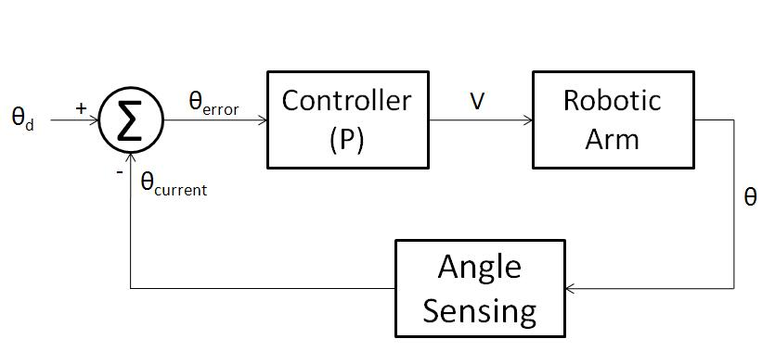
Figure 5 - Block diagram of control system for functional prototype

In addition to determining the magnitude of the response, our motors must also know which direction to turn. Direction is accomplished by determining the sign of the quantity e(t) and sending a corresponding high or low signal to the motor direction line.
4.9 Implementation
Our project requires successful integration of motors, sensing, and control theory. For our functional prototype, we chose a simple circuit and C-programming of the MaEvArM microcontroller to integrate our ideas.
4.10 Circuitry
Our breadboard functional prototype circuit consists of a half-H bridge integrated circuit (IC). This IC serves as the motor driver. On each side of the IC, there is an enable line, two direction lines for bidirectional control, and motor output lines. We use control theory to command a PWM signal to the enable line and error sign to send a high or low signal to one direction line on the IC. This signal is then passed through a NOT-gate on a 74HC04 hex inverter and sent to the second direction line on the IC. The IC processes the direction line signals to determine the voltage polarity to send to the motor. The ability to change the voltage polarity (which motor lead receives V⁺ and which motor lead receives GND) allows for bidirectional control.
Figure 6 shows a circuit diagram for our functional prototype. Power comes from the V⁺ and GND lines of the microcontroller when it is connected by a USB cable to the computer.
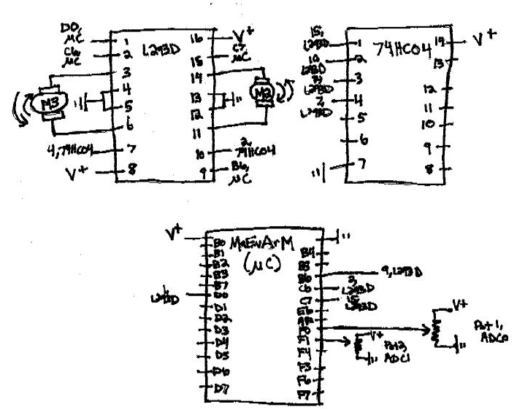
Figure 6 - Circuit diagram for functional prototype

4.11 Programming
Commands from the MaEvArM microcontroller are given using C programming and the microcontroller details. Appendix 10.3 contains the commented code programmed to the microcontroller for our functional prototype.
4.12 Mechanical Configuration of Prototype Arm

The physical design of the arm of the functional prototype consists of 3 planar rotating links connected to a base, as shown in Figure 7. The links were made from acrylic using the laser cutter.

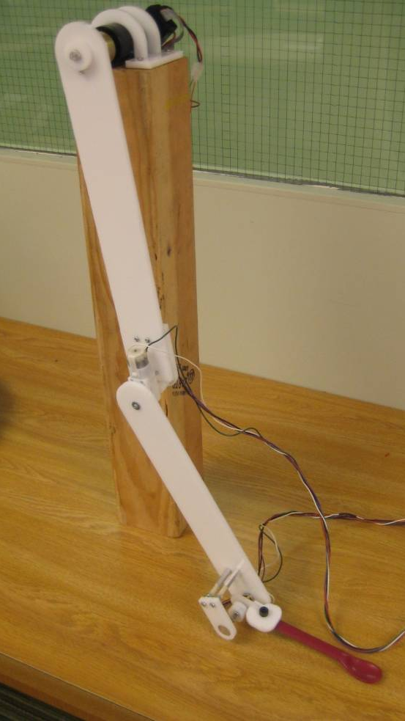
Figure 7 - Preliminary prototype of our robotic linkage

The base motor is attached to the first link by a D-shaft extension fitted into a D-cutout on the acrylic link. A set screw collar secures the link to the shaft (Figure 8a). The second link is attached in a similar manner, but a potentiometer is also coupled to the motor shaft by a circular coupling. (Figure 8b) Rotary movement of the motor causes proportional rotary movement of the potentiometer, which provides position feedback to the controller. The third link controlling the spoon end effector movement is attached similarly (Figure 8c). The base motor does not require a potentiometer coupling because it has built in encoders which can provide position feedback.

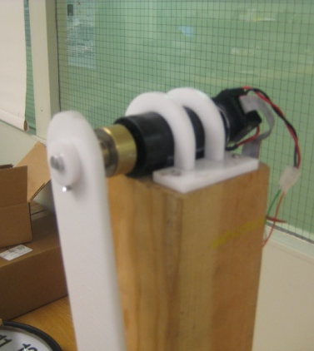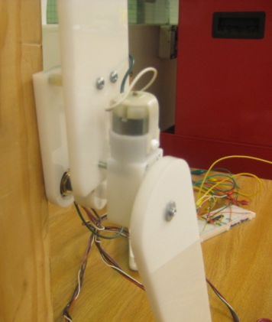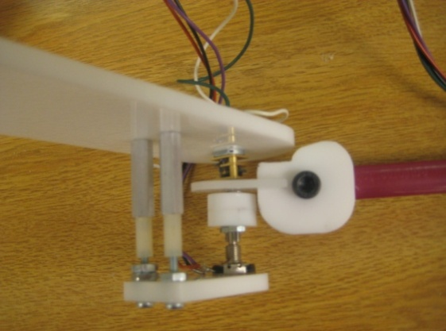
Figure 8 (a-c) - Motor attachments for the base link, link 2, and link 3 (spoon end effector link)

5. Testing and Evaluation

In the spring, the final feeder will be testing for the following basic criteria:

- Does the product deliver food without spilling?
- Does the product deliver food accurately?
- Is the product easy to set up?
- Are product functions intuitive to the user?
- Is the product safe?

To test the first criterion, the feeder will be set up on a table for normal use. The feeder routine will then be activated, and the arm will deliver food from the bowl to a predetermined position. The test will be considered successful if the arm can deliver the food without spilling any of the food on the end effector spoon unless the food falls back into bowl of the feeder. This test will be completed with foods of various consistencies, including mashed potatoes, chopped vegetables, and pudding.

The second criterion (accurate food delivery) will be tested by comparing the arm’s demonstrated end positions to the desired end position The device must achieve the desired end position within 3cm in 3D space. This test ensures that the feeder will deliver food within 3 cm of the user’s mouth. The target users for this device can move their heads a limited distance; they are capable of moving 3cm to obtain food from a spoon.

The ease of set-up will be tested using feedback and reviews from faculty at the HMS school. In addition, the device will need to be set up in less than 5 minutes. Set-up time runs from the time that the device is placed on the table to the time when the device is plugged in, the height is adjusted, and the user is ready to begin feeding.

To determine if the product functions are intuitive to the user, we will also seek feedback from feeding specialists at the HMS school. The HMS school students have tested multiple feeding devices, like the Winsford Feeder and the Mealtime Partner. Faculty at HMS are experienced in these types of feeders and will be able to provide valuable feedback to ensure that this device would be understandable to the target user.

We also want to ensure that, if the device is hit and potentially moved from its intended base position, the arm will not harm the user or anything or anyone else nearby. If the control system notices any behavior that deviates from planned trajectory, the arm will immediately shut down. To test the product’s safety, we will knock each of the links of the product. The product will pass this test if the links stop moving in less than 2 seconds.

For safety and liability reasons, we do not intend to test the final product on an actual student at the HMS school. All testing of the products’ movements will be completed without a human tester. This product has been designed with certain target students in mind in the hopes that one day this device could be tested on such a student.

6. Bill of Materials
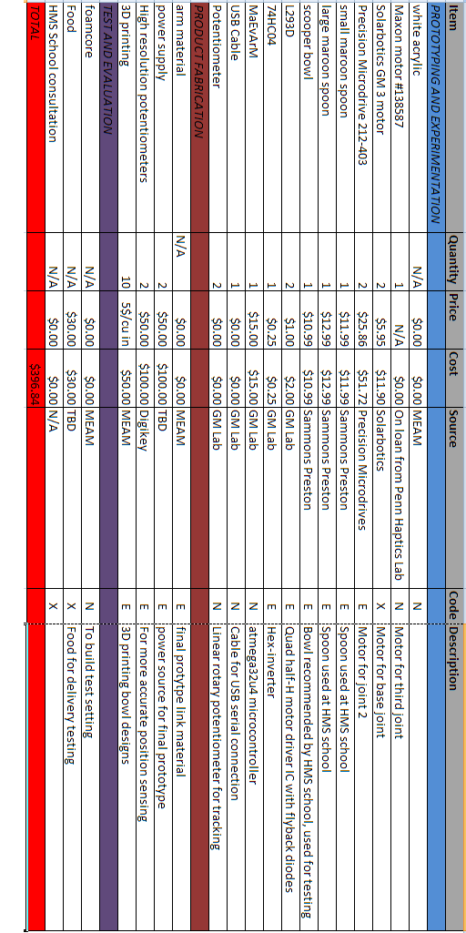
7. Project Plan
7.1 Gant Chart
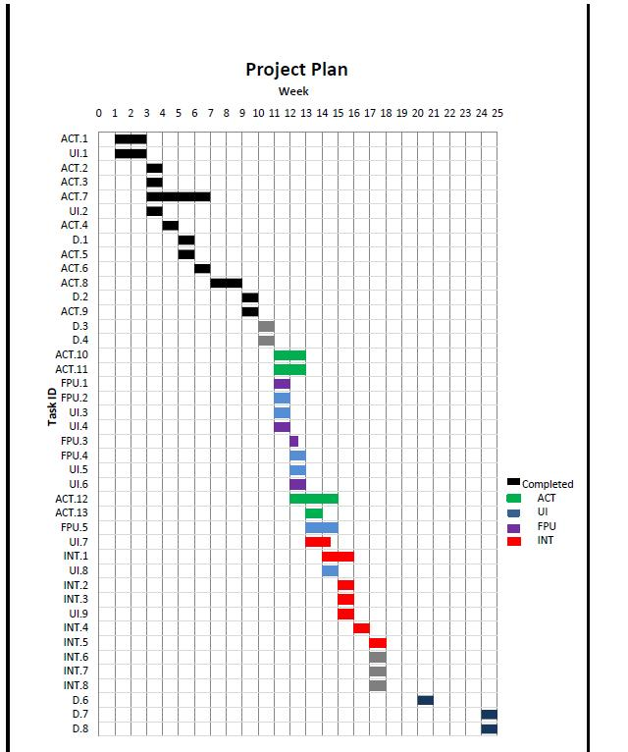
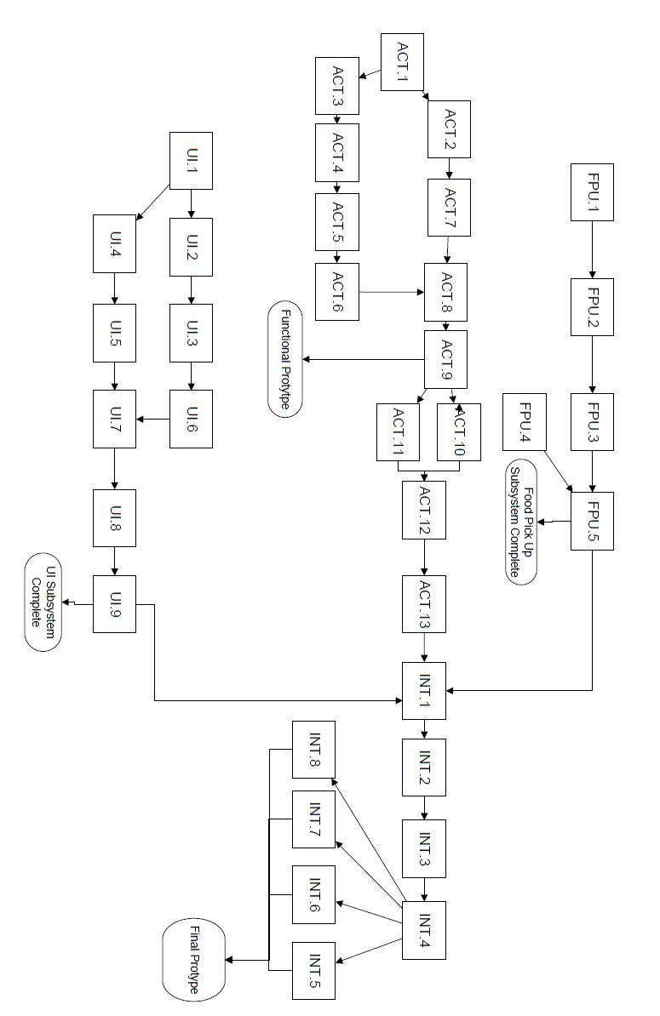
7.2 Activity Network

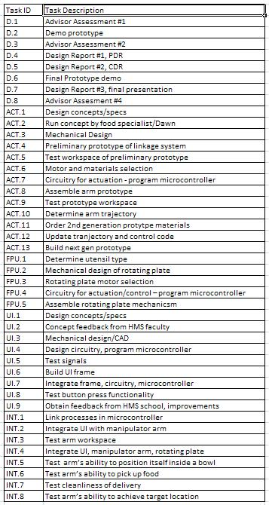
7.3 Task List

8. Risks
The main risks and ways we plan to prevent and handle are summarized in Table 2.
Risk | Preventative Measures | Recovery
Using an interface that is unfamiliar to the students. | Making the interface as close as possible to what they already have. Get feedback from school faculty and nutritionist. | Choose a simpler user interface option.
Motors can be dangerous. | Doing thorough testing and planning to assure that the motors will not be in dangerous locations. | Adjust the design and cover the motors where necessary.
Being able to pick up all the food from the bowl. | Designing a bowl that will allow the food to constantly be in a position that the spoon can pick it up. | Having an aide come and scrape the sides one time during each meal.
Spoon impacting the student  . | Testing the device and having a set limit of how close the spoon may get to the student. | Increase the factor of safety and make the distance the spoon may get to the student farther.
Obtaining a smooth trajectory | Test often visually to ensure smoothness. Define many points along trajectory. | Continue to set more points along the trajectory.

Table 2 - Risks and Preventative Measures

9. 1 References
Dormans JP, Pellegrino L. 1998. Caring for Children with Cerebral Palsy: A Team Approach. Baltimore: Paul H. Brookes Publishing Co.
9.2 Acknowledgements
We would like to acknowledge the contributions of our advisors: Dr. Katherine J. Kuchenbecker, Dr. Robert Jeffcoat, Dawn Rainey, and Marianne Jones.
We would also like to acknowledge the help we received from Dr. Vijay Kumar, Dr. Jonathan Fiene, and Joe Romano.

10. Appendices
10.1 Joint Angle Calculation
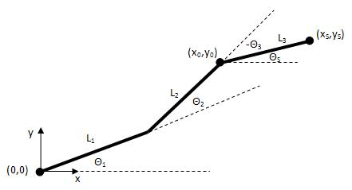
Figure A1 - Sketch used to define the joint angles for the robotic arm

- Choose location of end effector (x_{S},y_{S})
- Choose spoon angle (Θ_{S})
- Solve for (x₀,y₀)
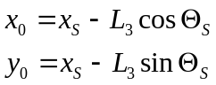
- Solve for Θ₂
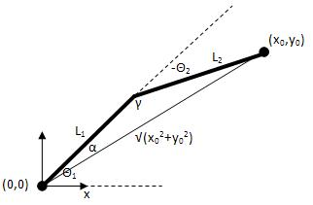
Figure A2 - Sketch showing the first and second link in an "elbow up" configuration
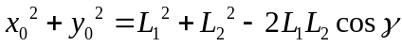
Define the arm to always be in an “elbow up” configuration to avoid inference with table and bowls.
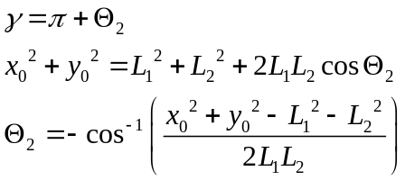
- Solve for Θ₁
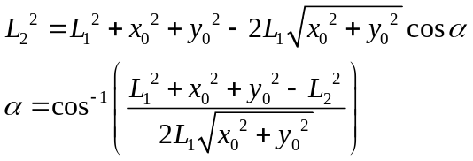
Again, choose the “elbow up” solution.
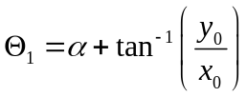
- Solve for Θ₃
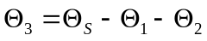

10.2 Motor Torque Calculation Script
% MOTOR TORQUE CALCULATIONS
% assumes: uniform rectangular cross sectional area, link lengths end at
% joints, motors located at joints, first motor rigidly connected to base
% (weight of motor 1 not a factor)

% CONSTANTS:
% acceleration due to gravity [m/s^2]
g=9.81;

% INPUT VARIABLES:

% weights of motors [N]
W1=0.07*g;
W2=0.07*g;
W3=0.07*g;
% weight of food [N]
Wf=0.05*g;
% weight of spoon [N]
Ws=0.05*g;
% length of spoon [m]
Ls=6*.0254;
% length of links [m]
L1=13*.0254;
L2=10*.0254;
L3=0;
% thickness of links [m]
b1=0.25*.0254;
b2=0.25*.0254;
b3=0.25*.0254;
% height of links [m]
h1=2*.0254;
h2=2*.0254;
h3=2*.0254;
% density of link material [kg/m^3]
rho1=1.17/1000*100^3;
rho2=1.17/1000*100^3;
rho3=1.17/1000*100^3;
% number of parallel links [-]
n1=1;
n2=1;
n3=1;

% CALCULATED VARIABLES:

% volume of links [m^3]
V1=n1*L1*b1*h1;
V2=n2*L2*b2*h2;
V3=n3*L3*b3*h3;

% weight of links [N]
WL1=rho1*V1*g;
WL2=rho2*V2*g;
WL3=rho3*V3*g;

% OUTPUTS:
% torque on each motor [N-m]
T1=Wf*(Ls+L3+L2+L1)+Ws*((Ls/2)+L3+L2+L1)+WL3*((L3/2)+L2+L1)+W3*(L2+L1)+WL2*((L2/2)+L1)+W2*L1+WL1*(L1/2);
T2=Wf*(Ls+L3+L2)+Ws*((Ls/2)+L3+L2)+WL3*((L3/2)+L2)+W3*L2+WL2*(L2/2);
T3=Wf*(Ls+L3)+Ws*((Ls/2)+L3)+WL3*(L3/2);

motor_torques_in_oz=(1/9.81*35.27/.0254)*[T1;T2;T3];

10.3 Microcontroller Code
// Senior Design: HMS Robot Arm Controller

// Include pre-defined routines

#include "maevarm.h"
#include "usb_serial.h"
#include <avr/interrupt.h>
#include <util/delay.h>

//Initialize variables
int ADC_to_degrees_SMALL = 3; //degrees/decimal=0.3 for small shaft pot (joint 3)
int ADC_to_degrees_LARGE = 24; //degrees/decimal=0.24 for large shaft pot (joint 2)
int theta_deg_3=0;
int theta_deg_2=0;
int K_p_3 = 6;
int K_p_2 = 10;
int theta_desired_3 = 180;
int theta_desired_2 = 90;
int duty_cycle_3=0;
int duty_cycle_2=0;

void init(void);

int main(void)
{
set(DDRE,6); // red LED enabled
set(PORTE,6); // red LED off
init();
while(1){

///ADC JOINT 3

//Select analog input: ADC0 on F0
clear(ADCSRB,MUX5);
clear(ADMUX,MUX2);
clear(ADMUX,MUX1);
clear(ADMUX,MUX0);
//Start conversion
set(ADCSRA,ADSC);
//Check ADC flag: has conversion occurred?
while(!check(ADCSRA,ADIF));
//Convert ADC results to degrees
theta_deg_3 = ADC*ADC_to_degrees_SMALL;
theta_deg_3 = theta_deg_3/10;
//reset flag to be low
set(ADCSRA,ADIF);

///ADC JOINT 2

//Select analog input: ADC1 on F1
clear(ADCSRB,MUX5);
clear(ADMUX,MUX2);
clear(ADMUX,MUX1);
set(ADMUX,MUX0);
//Start conversion
set(ADCSRA,ADSC);
//Check ADC flag: has conversion occurred?
while(!check(ADCSRA,ADIF));
//Convert ADC results to degrees
theta_deg_2 = ADC*ADC_to_degrees_LARGE;
theta_deg_2 = theta_deg_2/100;
//reset flag to be low
set(ADCSRA,ADIF);

//Correct for error

duty_cycle_2 = abs(K_p_2*(theta_desired_2-theta_deg_2));
if (duty_cycle_2>255){
duty_cycle_2=255;
}
duty_cycle_3 = abs(K_p_3*(theta_desired_3-theta_deg_3));
if (duty_cycle_3>255){
duty_cycle_3=255;
}

if ( (theta_desired_3-theta_deg_3) > 0) {
OCR0B=duty_cycle_3;
set(PORTC,6);
}else if ( (theta_desired_3-theta_deg_3) < 0) {
OCR0B=abs(duty_cycle_3);
clear(PORTC,6);
}else if (duty_cycle_3==0){
OCR0B=0;
}

if ( (theta_desired_2-theta_deg_2) > 0) {
OCR1B=duty_cycle_2;
set(PORTC,7);
}else if ( (theta_desired_2-theta_deg_2) < 0) {
OCR1B=duty_cycle_2;
clear(PORTC,7);
}else if ( (duty_cycle_2==0) ){
OCR1B=0;
}

/////////READ ADC VALUES ON COMP SCREEN!
usb_tx_char( (char)(theta_deg_2>>8));
usb_tx_char( (char)theta_deg_2);
//usb_tx_char(ADCL);
//usb_tx_char(ADCH);
clear(PORTE,6);
_delay_ms(100);
set(PORTE,6);
_delay_ms(100);

}
}

void init(void)
{

//Set Pin C6,C7 as outputs for motor directions
set(DDRC,6);
set(DDRC,7);

clear(PORTE,6);//turn LED on
usb_init();
_delay_ms(100);
while(!usb_configured());

//Set clock prescaler (8000000/ 2^n)
CLKPR = (1<<CLKPCE);
CLKPR = 3;

////////Set up ADC for pot on pin F0

//Set the voltage reference to Vcc
clear(ADMUX,REFS1);
set(ADMUX,REFS0);
//Set ADC clock prescaler (/16)
set(ADCSRA,ADPS2);
clear(ADCSRA,ADPS1);
clear(ADCSRA,ADPS0);
//Disable digital inputs
set(DIDR0,ADC0D);
set(DIDR0,ADC1D);
//Enable "free-running" mode
//set(ADCSRA,ADATE); no free running mode = change MUX bits in while(1) loop
//Enable conversions
set(ADCSRA,ADEN);

/////////Set up timer 0 for motor 3 output from pin D0

//Set D0 as output for OCR0B
set(DDRD,0);
//Set B7 as output for OCR0A
// set(DDRB,7);
//Set clock prescaler (System clock/64=15625Hz) = timer overflows every .016s
clear(TCCR0B,CS02);
set(TCCR0B,CS01);
set(TCCR0B,CS00);
//Set mode: UP to 0xFF, PWM mode
clear(TCCR0B,WGM02);
set(TCCR0A,WGM01);
set(TCCR0A,WGM00);
//Clear at OCR0B, set at 0xFF, allowing this value to control the duty cycle
set(TCCR0A,COM0B1);
clear(TCCR0A,COM0B0);

////////Set up timer 1 for motor 2 output from pin B6

//Set B6 as output for OCR1B
set(DDRB,6);
//Set B5 as output for OCR1A
set(DDRB,5);
//Set clock prescaler (System clock/64=15625Hz), see above
clear(TCCR1B,CS12);
set(TCCR1B,CS11);
set(TCCR1B,CS10);
//Set mode to be same as for motor 3: UP to 0xFF, PWM mode
clear(TCCR1B,WGM13);
set(TCCR1B,WGM12);
clear(TCCR1A,WGM11);
set(TCCR1A,WGM10);
//Clear at OCR1B, set at rollover
set(TCCR1A,COM1B1);
clear(TCCR1A,COM1B0);

}

This determined from lunchtime observation at the HMS school and interviews with Marianne Gellert-Jones, MA, CCC/SLP, Feeding Specialist at the HMS School for Children with Cerebral Palsy.

