Zach Meister, Ryan Menezes
Prof. Ben Taskar
CIS 520
2 December 2009
Final Project Report
Blogs
We first tried to improve the NB baseline by simple changes to the feature space. In doing so, we repeatedly introduced suspected (mild) violations of the “naïve” assumption because we read that NB performs well in spite of this. The first features we added were document length, maximum word length, and average word length. The baseline expected boolean features, so we chose thresholds for these values. In review we see we had a bad approach because our cross validation was manual and incomprehensive and because the few features we added were far outweighed by the sheer number of dictionary word features. Consequently the model performed approximately at baseline (Table 1, average + max).
We continued our attempts to add useful features to the NB baseline by adding bigrams. The large number of bigrams in the training set motivated our first dimensionality reduction via stemming. The Porter stemmer cut down the number of features from 89,182 to 57,049. The number of bigrams was still too large so we restricted the feature space to the first 500,000 bigrams encountered in the training data. Although our model had this undesirable restriction it performed well and ended up being our final submission (Table 1, stem + bigram).
Now we began to see that we should take steps to avoid memory overconsumption and runtime inefficiency. To reduce memory use we tried dimensionality reduction via LDA, but this took too long to compute (even over the stemmed feature space). Sadly we didn’t think to eliminate the large number of infrequent words until too late—we should have paid more attention to the advice about the importance of visualization. To reduce runtime compared to bigram generation we implemented a sequence kernel, but its runtime was also too long (http://jmlr.csail.mit.edu/papers/volume3/cancedda03a/cancedda03a.pdf). Finally, after these failed attempts at dimensionality reduction we decided to try something completely different from the NB baseline. We quickly implemented a K-Nearest Neighbors algorithm with no preprocessing (Table 1, 100 nearest).
Table 1: Blogs errors, bold if better than baseline.

 |  | Training error | Validation error | Test error
average + max | age | 0.8447 | 0.7150 | -
 | gender | 0.9693 | 0.7100 | -
stem + bigram | age | 0.8540 | 0.7150 | 0.726
 | gender | 0.9867 | 0.7350 | 0.742
100 nearest | age | - | 0.6550 | -
 | gender | - | 0.4900 | -

At this point we realized that one of our problems was that we didn’t deal with any one blogs model long enough and systematically enough to train it properly. Instead of experimenting with KNN using different values of k and different types of preprocessing, we decided to make a fresh start. Based on intuition and visualizations of the training data we preprocessed the data by stemming words, eliminating stop words (as suggested in Cancedda et al.), and eliminating infrequent words. Then, using the pre-processed data, we implemented a kernelized regression. This was all done with automatic and comprehensive cross-validation in mind. Figure 1 shows the LOOCV error for fixed preprocessing steps and varying values of sigma (Gaussian kernel). This was as far as we got in our fresh and proper approach because it was time to submit the final code.
Figure 1: LOOCV error over Gaussian kernel widths.
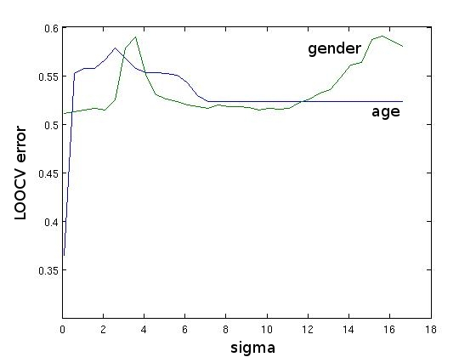

Images
The first attempt to improve on the images baseline was to use SIFT features in place of pixels. SIFT features are by name scale invariant, and are by reputation rotation invariant, shift invariant, and partially invariant to light changes and affine distortions in images. These properties are apparent in the visualizations of SIFT features given in Figure 2. Given the popularity of SIFT features in object recognition we assumed that these features would be a very powerful way to determine the common features of a face based on the age and gender of an individual. Since there’s no guarantee when using SIFT features that any two images will have the same number of features, we decided to use histograms created by a clustering algorithm to create a new feature space.
Figure 2: Visualizations of SIFT features for faces with different orientations.
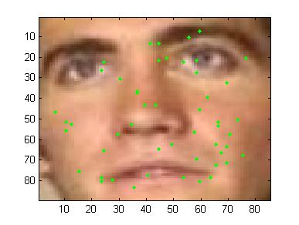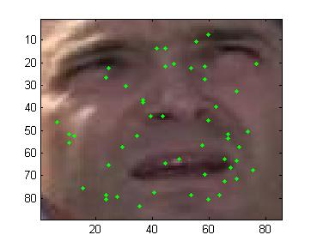
The VLFeat package (www.vlfeat.org) offered not only a means of quickly extracting SIFT features from an image, but also a method of clustering them, namely the Hierarchal K-Means algorithm. Hierarchal K-Means constructs a tree where the root is a standard clustering of the input data on K features, and each subsequent level is constructed by reclustering the data at each leaf node into K clusters. Each level of the tree is therefore a more detailed clustering of the original data until at some point, if the algorithm is not limited by a maximum number of leaf nodes, each piece of input data will be its own cluster. Histograms on the Hierarchal K-Means tree allow for large vectors of features where parts of the vector can be weighted to emphasis certain levels of the tree. Our SIFT feature histograms were 1111 vectors, and were used as the features passed to the SVM, still running with a radial basis function kernel.
The algorithm was trained using a subset of the training data and a set of virtual examples which were defined as horizontal flips of the training subset. The training accuracy for this method was usually 100 percent, with the test errors for test subsets of the training data averaging at 60 percent for ages and 80 percent for gender. Unfortunately, this method did not break any baselines on the real test data. Although the reason for this problem was never fully determined, barring any tremendously unusual test data the problem with this method was most likely a kernel that was not sophisticated enough to handle the SIFT feature histograms that we were using. Although we tried using the histograms with polynomial kernels and linear kernels, neither was more successful than the radial basis function kernel. With this in mind, our next attempt to improve on the algorithm was to provide it with a pyramid match kernel.
The goal with this attempt was to implement a pyramid match kernel in MATLAB and input the kernel matrix as a precomputed kernel matrix for the provided SVM. No implementation of the pyramid match kernel could be found that was easy to interface with MATLAB, so we attempted to build our own based on the description of pyramid match kernels found in “Beyond Bags of Features: Spatial Pyramid Matching for Recognizing Natural Scene Categories” by Svetlana Lazebnik, Cordelia Schmid, and Jean Ponce. This method never got off the ground however, due to insufficient memory for performing the calculations in MATLAB. With the due date rapidly approaching we decided it best to avoid attempting an interfacing between a complicated C++ implementation of the spatial pyramid match kernel, and left the implementation of a new kernel as a failed experiment.
Our final submission consisted of a very simple fix to the code, altering it so that the images being considered were properly cropped prior to shrinking and feature extraction. We trained the model on the full training set and a full set of virtual examples, and the results were considerably better than any other method we had tried. Several different built in kernels were tried here as well, and we found that the radial basis kernel was indeed the best kernel for pixel features.

