Jay Gupta
Katie Gibson
Alex Roederer

CIS 520: Machine Learning Project
The Hawaiian Mafia

This paper will discuss the techniques implemented with the aim of improving gender and age prediction on the provided corpus of text, culled from various internet blogs, and a corpus of facial images, also culled from the internet.
The baseline provided for the blogs portion project was a Naive Bayes model, specifically a Multi-Variate Bernoulli Model which, after training on the provided training set, classified the gender of the blog authors in the test set with 70.2% accuracy, and age with 73.2% accuracy. The baseline for the image portion was a Support Vector Machine implementation with a radial basis function kernel, and a slack parameter determined by 6-fold cross validation. The SVM predicted the age group of the people in the images with 48.6% accuracy and gender with 71.8% accuracy.
As we were only given access to the test set at specified times, much of the data used to evaluate the performance of classifiers in the rest of this paper comes from cross-validation, performed by reserving 10% of the training set, training on the remaining 90%, testing the trained classifier on the reserved examples, and computing the percent correctly predicted. Unless otherwise specified, the accuracy percentages below were calculated using this method.

Analysis

Initial analysis of the provided data sets showed considerable noise in the data; unique words were a core feature to be analyzed in the blog data, yet several of the blogs were in foreign languages (meaning that each of these blogs contains nearly 100% new words, unseen in any other blog). To reduce this noise, several techniques were considered. Manually removing the most egregious of the blogs (blogs that appeared to be in foreign languages or contain mostly “garbage” characters) seemed to increase the cross validation age accuracy of the basic Naive Bayes classifier by 2% to 5%, but also seemed to decrease the gender accuracy between 2% and 7%. Stemming to reduce the dimensionality of the data by mapping words with the same stem together caused similar, unstable fluctuations in the accuracy of the classifiers. Similarly, image data suffered from noise due to poorly cropped background and imperfect alignment of facial features (slight rotations/scalings). Cropping the images to include only the faces (at the exclusion of hair information, neck information, and background) improved the classification accuracy significantly.
To improve the baseline scores for image data, we first fixed the bug that caused images to be processed uncropped in the provided SVM classifier, producing a considerable jump in performance. To further improve performance, training set images were replicated through simple horizontal mirroring to produce flipped-face data, producing virtual examples. These virtual examples helped to prevent overfitting by reducing variance caused by factors such as the direction of the light source on the face. These two changes alone improved baseline age prediction accuracy on images by 4%, and improved baseline gender prediction accuracy by 7%.
Further attempts to improve the images classifier were made, but due to the problems that we were having with the blog classifier these further attempts were halted in their infancy in favor of improving the blog classifiers. We computed the discrete wavelet transform of each image using Haar wavelets, as well as the integral image of each face. Unfortunately, we did not have more time to invest in these methods, and classifiers were never constructed that would use these new feature spaces.
Initial attempts to improve baseline scores regarding the blog data involved implementation of a wide variety of generative and discriminative classifiers. Initially, an attempt at implementing Latent Semantic Analysis (LSA) [4], utilizing a singular value decomposition to produce the necessary eigenvalues/vectors, failed due to the large size of the feature space; attempting to perform LSA with a full feature space of words (over 84,000 words) exhausted Matlab's memory capabilities. Though attempts to streamline the algorithm/utilize the sparseness of the matrix were made, in the interest of time, a simpler initial attempt to improve on the baseline was made with a support vector machine implementation.
The support vector machine implementation used here was a standard implementation, similar to the implementation utilized in our previous homework assignment. In order to reduce the dimensionality of the data, the Naive Bayes prediction algorithm was used to choose the most likely features; features were ordered by their probability of occurrence, and the top 1000 were selected for use with the SVM algorithm. The SVM classifier performed fairly poorly, achieving only approximately 50% accuracy on gender and 33% age accuracy, which is no better than random categorization. This was fairly unsurprising, as we doubted a linear classifier would be able to split the data effectively.
Prompted by Koppel's paper [3], a simple implementation of a basic Winnowing algorithm was completed. The Winnowing algorithm involves iteratively updating a set of weights, one for each feature in an example. Given such an example, the weights are multiplied by it and the output is used to classify; if the prediction is wrong, the weights are updated to compensate. The process is repeated for each example, until a set of training weights is produced. The winnowing algorithm is similar to the perceptron algorithm covered in class, but uses a multiplicative weight-update scheme rather than an additive update scheme, purported to be advantageous when many of the features are irrelevant (as we posit is true of the blog data). However, successful categorization rates when cross validation was performed were not as high as those achieved in the paper; the classifier was only slightly better than random guessing at both gender prediction and age prediction, with the test accuracies observed at 56% and 40% respectively. Possible explanations for this poor performance may include the extent to which the data was dirty, or simply too restrictive a feature set (as the Winnowing algorithm utilized the “highest likelihood” words as predicted by the Naive Bayes classifier).
The baseline Naive Bayes implementation for blog classification uses what is called the Multi-Variate Bernoulli model, which looks at whether or not each word in the dictionary occurred in any particular blog. An alternate Naive Bayes model is the Multinomial Event Model. This model captures word frequency in addition to occurrence. In short, instead of parameterizing the words of the document as $P(x,y)=\prod_{i=1}^{M}{P(X_{i}=x_{i}|Y=y)}$where M is the number of words in the dictionary and
x_{i} [0,1], we have parameterized the words of the document as $P(x,y)=\prod_{i=1}^{L}{P(X_{i}=x_{i}|Y=y)}$where L is the length of each blog and x_{i} {1, …, M}. We decided to implement this model since it has been shown to perform better for text classification [1]. Cross-validation results produced high training set accuracy: 90% on age classification and 94% accuracy on gender; but test accuracy was only 68% and 72% on age and gender respectively, slightly lower than the accuracy achieved by the Naive Bayes baseline. While the multinomial event model usually outperforms the Multi-Variate Bernoulli model given a large enough dictionary, results are also dependent on the training and test sets. Since the two models had fairly comparable performance, we concluded that this was just due to the particular data set, not an insufficient dictionary or mistake in our implementation.
In an attempt to improve the accuracy of the classifiers, we reduced the noise of the blog data by manually reviewing the blog data and deleting by hand the blogs that appeared to be written in foreign languages. For reference, the offending blogs removed were blogs number 57, 234, 463, 484, 532, 562, 700, 747, 809, 873, 876, 1297, 1308, and 1496. Results of the baseline NB ran on this reduced set were comparable to that of the NB run on the full data set, which was unsurprising, considering that removing distracting features does not result in an increase in available information, only a reduction of possible distracting information.
To reduce the dimensionality of the data in a more meaningful way, we adapted the Porter Stemmer, developed by Martin Porter, [2] and applied it to the raw blog data, resulting in a reduction of dimensionality from over 89,000 word features to just over 54,000 word features. As mentioned above, applying the porter stemmer to the data prior to running the basic NB implementation resulted in consistently high training accuracy (83.5% on age and 93% on gender), and an improvement in test accuracy: a 2% increase in gender accuracy, and a 1% increase in age accuracy over the baselines.
Boosting was performed using decision stumps that hinged on whether or not a word occurred in a blog as a basic classifier. As expected, performance was poor, with prediction rates in the low 50% range, accompanied by long runtimes. Prediction rates would likely have improved slightly over further iterations, but our feature set was large enough that the runtimes were unacceptable. These results convinced us that we needed to either find a new set of features to boost on, or reduce the dimensionality of the current set of features. Our first idea was to create a new set of features that would reflect language complexity. In order to do this, we counted the number of words of length 1 through 14, in addition to those with greater than 15 characters. This created a set of 15 features that we could then boost on. By doing so, test accuracy from cross validation actually improved to about 59% for age and 55% for gender. Unfortunately, this was accompanied by low training accuracy of around 64%. We know that low training accuracy as well as low test accuracy corresponds to a feature set that is too small, which agreed with our methods up to that point.
In order to further increase our feature set with meaningful and information-rich features, we then determined which words were more “important” than others. In order to do this, we first stemmed the data and then ascertained which words had the largest probability of occurrence, P(X). The 10 words with the greatest P(X) values are shown in the first two columns of Table 1, at the end of this report. As is immediately obvious, since these words occur in almost all blogs, they would not be useful classifiers. What we were more interested in were words that not only had large P(X) values but also had large differences between P(X|Y=y) for different y values. Words that had large differences between P(X| Y_{gender}=male) and P(X| Y_{gender}=female) are tabulated below. In addition, words that had large differences between P(X|Y_{age}=1) and P(X|age≠1) as well as differences between P(X| Y_{age} =2) and P(X|Y_{age}=3) are tabulated in Table 1.
In each case we found words that were both high on the list of words that had large P(X) values and had large P(X|Y=y) differences. We then used the first 500 or so “important” words and boosted on those features in addition to word length. Since age was multi-class, we first boosted on words that separated age group 1 from the other two groups and then used boosting on the data classified as not being from age group 1 in order to separate age group 2 from age group 3. The resulting first 15 features that were boosted on are shown in Table 2. This lead to a training accuracy of around 77% for both age and gender and about 65% and 68% test accuracy for age and gender, respectively. Representative training and test error curves for this implementation are shown in the figures at the end of this report.
As we had not yet achieved any sort of dramatic improvement, we decided to implement an instance-based method. The simple k-means algorithm was chosen for our initial attempt. The data was processed to reduce dimensionality (using both stemming and, in a separate attempt, the “highest likelihood NB” words) and the k-means algorithm was performed with 20, 30, and 50 means. (Larger numbers of means were tried initially, but the classifier's variance increased dramatically as the number of means increased, producing poor results.) Results for the k-means classifier were surprisingly low, with approximately 30-33% training and test accuracy on age, and 50-51% training and test accuracy on gender.

Final Classifiers

We incorporated into our final classifiers only the modifications that produced significant improvements in prediction accuracy, namely the stemming algorithm applied to the baseline Naive Bayes algorithm, and the baseline SVM implementation with increased training through the use of virtual examples and more accurate cropping. Though these were the simplest of the classifiers we developed, they persistently outperformed the more complicated algorithms.
Appendix

Table 1. P(X) values
P(X) | Words
0.9982 | a
0.9971 | on
0.9971 | to
0.9971 | of
0.9971 | the
0.9965 | it
0.9965 | in
0.9947 | .
0.9947 | and
0.9947 | ,

Table 2. Difference in P(X|Y=y) values, as well as their corresponding words
Gender |  | Age 1 v 2,3 |  | Age 3 v 2
|P(X|Y=1)-P(X|Y=2)| | Words | max(|P(X|Y=1)-P(X|Y=2)|, |P(X|Y=1)-P(X|Y=3)|, |P(X|Y=2)-P(X|Y=3)|) | Words | |P(X|Y=3)-P(X|Y=2)| | Words
0.173500166 | love | 0.302068765 | im | 0.163987093 | gui
0.146063971 | she | 0.274621212 | school | 0.136069024 | got
0.138490222 | her | 0.266433566 | don’t | 0.119107744 | oh
0.128629433 | girl | 0.263607226 | anywai | 0.114141414 | their
0.127800795 | cute | 0.249009324 | yeah | 0.112570146 | --
0.124549774 | tell | 0.248572261 | gonna | 0.109778339 | girl
0.12377914 | friend | 0.24504662 | oh | 0.105962402 | …
0.120055795 | post | 0.236713287 | fun | 0.105499439 | follow
0.117006408 | him | 0.233216783 | kinda | 0.105092593 | night
0.113896255 | urllink | 0.231497669 | stupid | 0.103002245 | where

Table 3. First 15 features boosted on for gender and age classification
Iteration | Gender | Age 1 v 2,3 | Age 3 v 2
1 | love | im | word length 1
2 | cute | school | word length 8
3 | ! | word length 9 | gui
4 | word length 7 | offic | husband
5 | eat | work | stupid
6 | because | word length 3 | …
7 | post | weekend | their
8 | she | word length 1 | coupl
9 | hair | fun | school
10 | game | move | --
11 | !! | bore | word length 4
12 | man | week | where
13 | him | someth | gave
14 | sometim | urllink | kinda
15 | 9 | stupid | follow

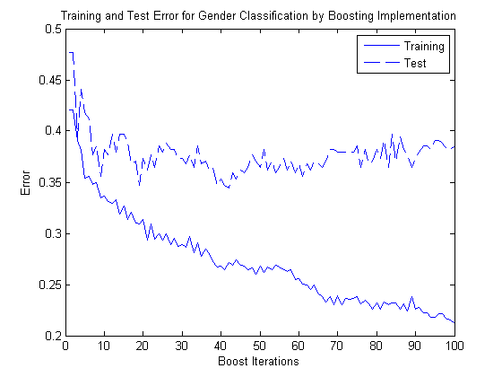

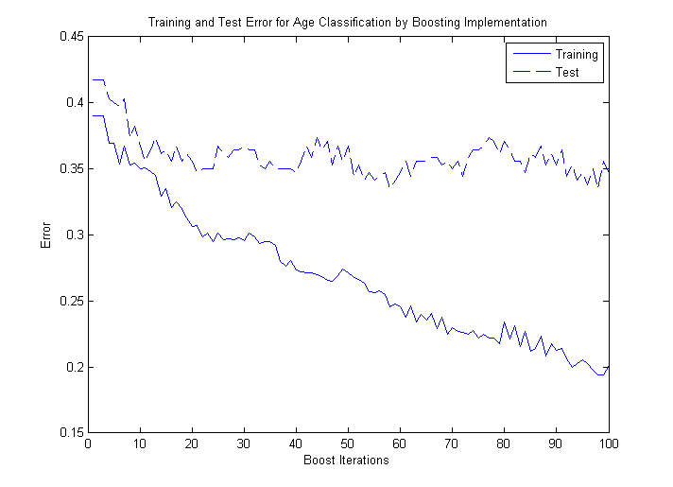

Bibliography

[1] A. McCallum and K. Nigam. 1998. A comparison of event models for Naive Bayes text classification. In Proc. of the AAAI-98 Workshop on Learning for Text Categorization, pages 41-48.

[2] C.J. van Rijsbergen, S.E. Robertson and M.F. Porter, 1980. New models in probabilistic information retrieval. London: British Library. (British Library Research and Development Report, no. 5587).
http://tartarus.org/~martin/PorterStemmer/

[3] M. Koppel, S. Argamon, A. Shimoni (2002). “Automatically Categorizing Written Texts by Author Gender”. Literary and Linguistic Computing, 17 (4): 401-412.

[4] S. Deerwester, Susan Dumais, G. W. Furnas, T. K. Landauer, R. Harshman (1990). "Indexing by Latent Semantic Analysis". Journal of the American Society for Information Science 41 (6): 391–407.

